Free-time activities (hobbies and sports)

1) Label the pictures with eight words from the box.
surfing the Net / ice skating / video games / jogging / taking photos / reading books / football / dancing / watching films / swimming / listening to music / athletics / drama / board games / basketball / cycling / rollerblading / ice hockey / gymnastics / drawing / fashion / skateboarding /


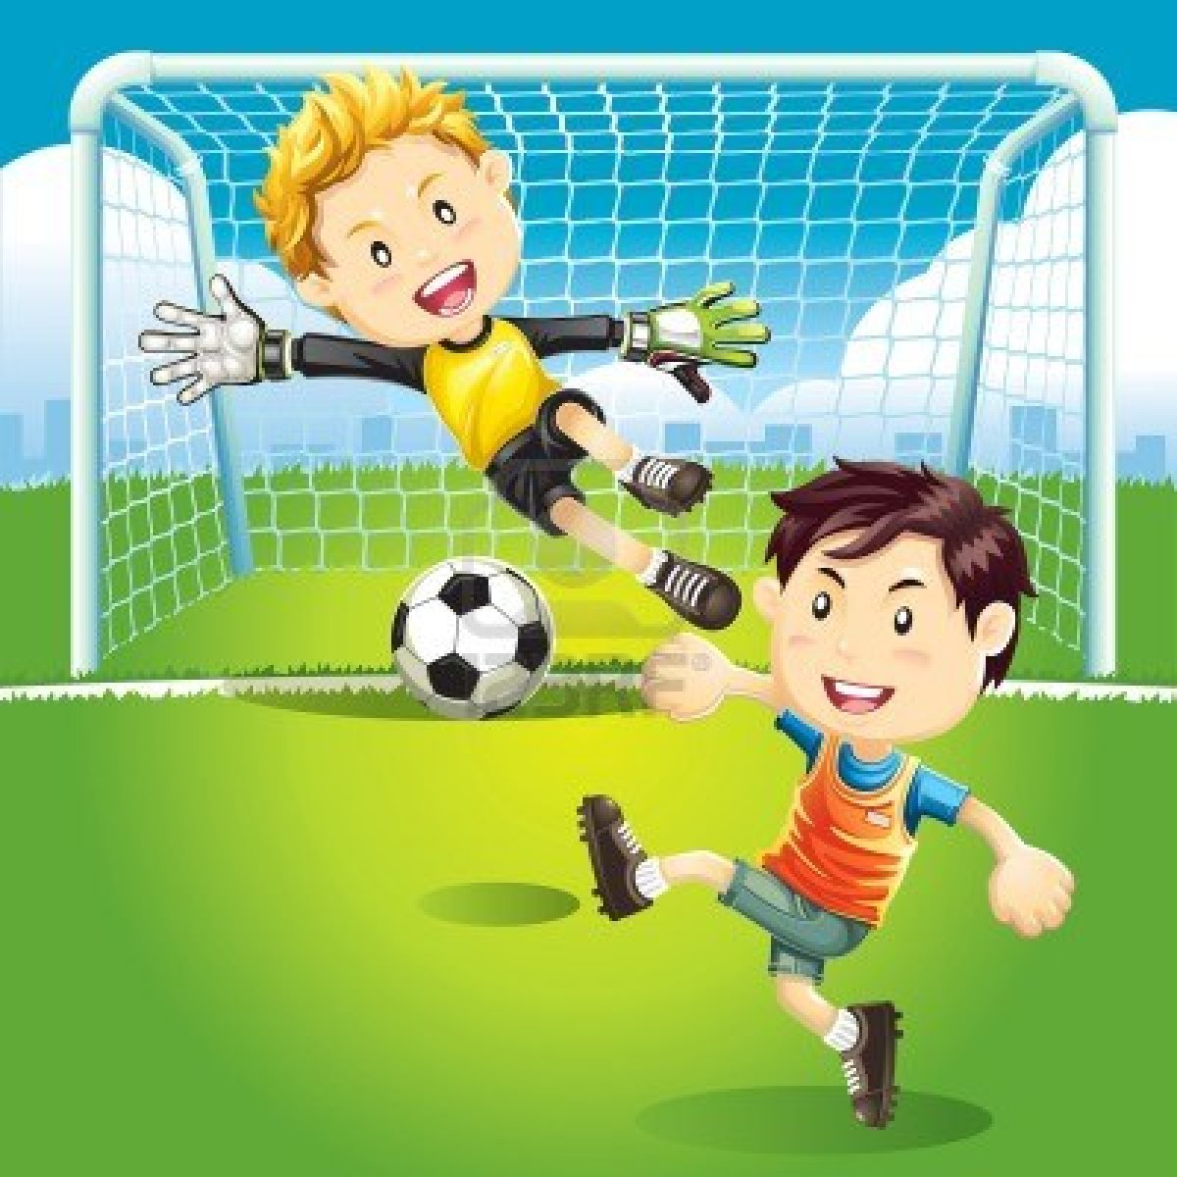

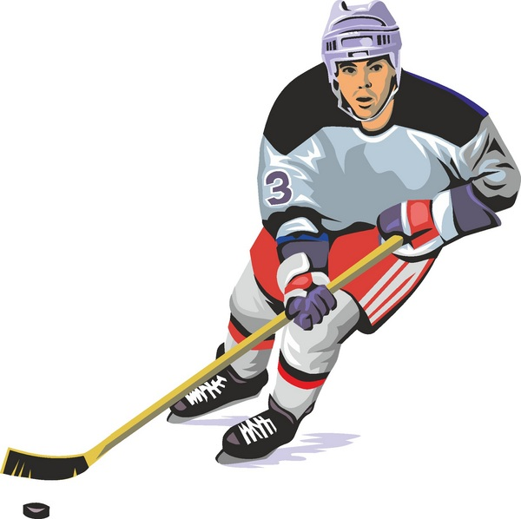
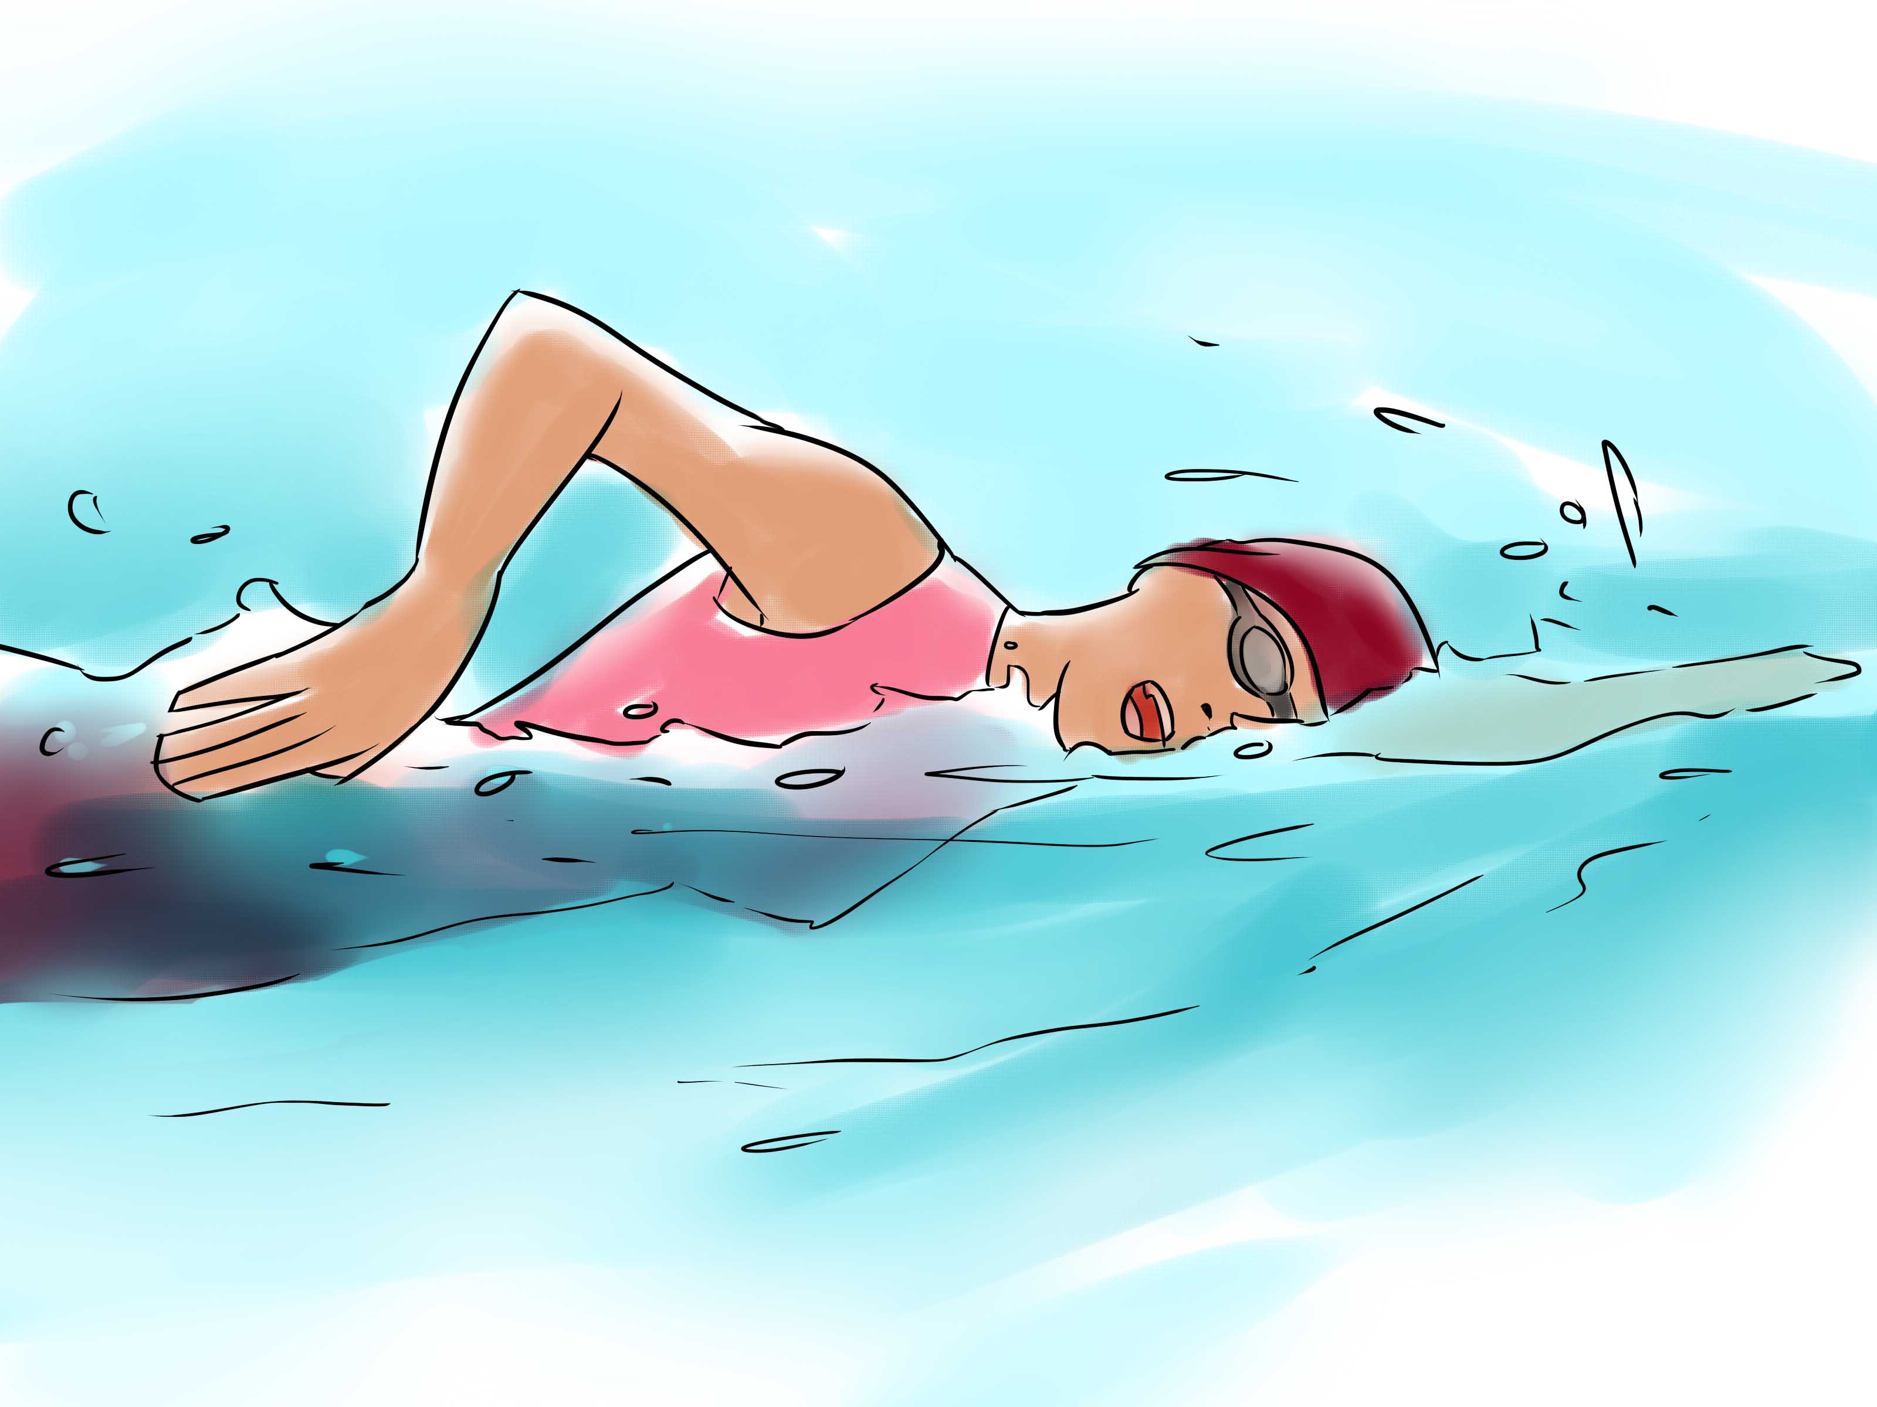

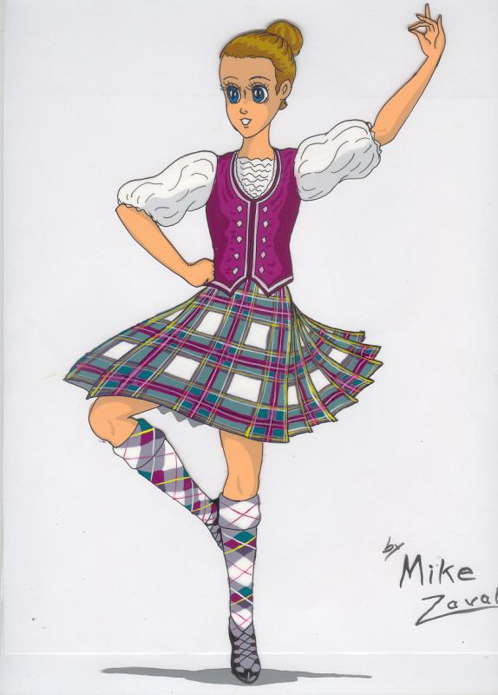
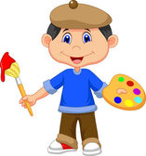
5_________
6________
7_________
8_________
2________
3_________
1________
4_________

2) Complete the sentences with the suitable words, two words are extra.
fashion / swimming / reading books / watching films / listening to music /
volleyball / surfing the Net / board games / go bowling / jogging

1. Ann’s really into ___________________________. She goes to the cinema every weekend.
2. I like __________________________. My favourite writer is Joanne Rowling.
3. Ted’s keen on __________________. He plays for the school team.
4. Sarah likes ________________________. Her favourite singer is Adele.
5. John is not very keen on ________________. He doesn’t pay any attention to new trends in clothes.
6. Dave’s really interested in ____________________. He likes looking at movie websites.
7. I quite like _____________________ - especially in the sea.
8. Jack doesn’t like playing __________________. He prefers outdoor games such as football.

3) Write three true sentences about the activities in ex. 1 and 2. Use the underlined phrases from ex.2
1. I ____________________________________ but I____________________________________________
2. I ____________________________________ but I ____________________________________________
3. I ____________________________________ but I ____________________________________________

4) Complete the sentences with do, play or go. Use the present simple tense.
With sports, we normally use:
Play- for team sports and ball sports.
I play basketball.
Go- for sports that end in
- ing He goes swimming.
Do- for individual sports not ending in –ing and with combat sports even if they end in – ing do gymnastics,
do karate, do boxing

1. Peter _________ tennis three times a week.
2. Sarah ___________ gymnastics on Saturday evenings.
3. Kate usually __________ rollerblading in the park.
4. Peter doesn’t _______ badminton with his friends.
5. He doesn’t ________ athletics at school.
6. We often _________ jogging in the morning.

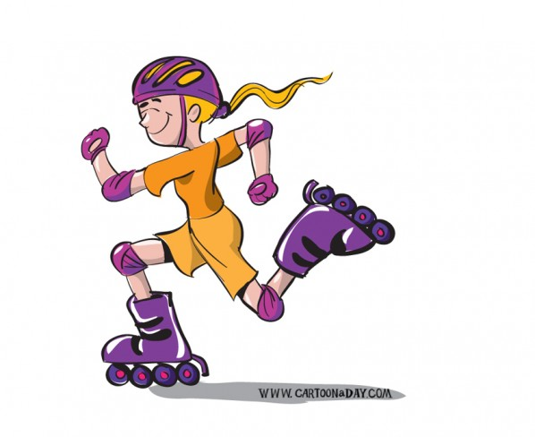

5) Underline the correct words.
1. I don’t do/play a musical instrument.4. We go for a film / a walk on Sunday evenings.
2. Tom likes surfing the computer/the Net.5. I’m keen on watching / doing sport on TV.
3. Jane does/plays gymnastics.6. He’s interested in doing/playing video games.

KEY

Ex. 1)
1 – football 2 – taking pictures 3 – drawing 4 – swimming 5 – reading books
6 – ice hockey 7 – surfing the Net 8 – dancing

Ex. 2)
1. watching films
2. reading books
3. volleyball
4. listening to music
5. fashion
6. surfing the Net
7. swimming
8. board games

Ex. 3)
Students’ own answers

Ex. 4)
1. plays
2. does
3. goes
4. play
5. do
6. go

Ex. 5)
1. play
2. the Net
3. does
4. a walk
5. watching
6. playing

